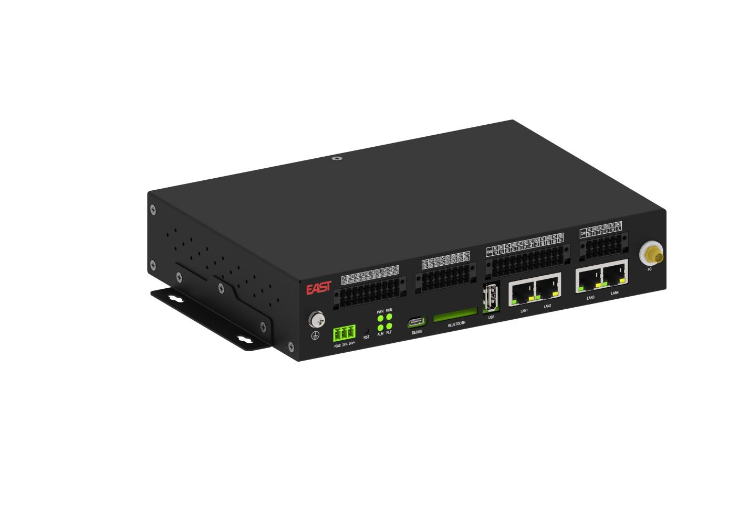
EMS智能网关
易事特EMS智能网关EAμEMS-DM206，具有采集与监视、统计分析、优化调度功能，可适用于发电侧、电网侧、用户侧多种场景，为储能行业提供全方位、立体化、系统性的系统解决方案。
EMS Smart Gateway
EAμEMS-DM206 EMS Smart Gateway features acquisition, monitoring, analysis and optimal scheduling. Suitable for generation, grid and user sides, it provides a complete, systematic solution for energy storage.

产品特点
功能丰富
- 64位处理器、ARM架构、主频最高2.0GHz，算力强大，实现区域独立自治
- 策略丰富：支持削峰填谷、需量控制、逆功率保护、计划跟踪、功率平滑等策略4路独立IP网口，适配电站双网及GOOSE专网
- 光储充一体化管理率

易于扩展
- 多种协议支持，支持103、104、IEC61850、GOOSE、MODBUS等各类标准协议接入
- 6路RS485，方便外扩IO、变送器等模块，
- 可选配4G等功能，实现全量设备接入
专业可靠
- 工业级核心板，无风扇免维护设计
- RT-linux系统，毫秒级数据采集处理
- 工业级严苛测试，工作稳定可靠

Product Features
Rich Functions
- 64-bit ARM processor up to 2.0 GHz for high performance & regional autonomous control
- Multiple operating strategies: peak shaving & valley filling, demand control, reverse power protection, schedule tracking, power smoothing, etc.
- 4 independent Ethernet ports for dual-network & GOOSE private network
- Integrated PV, energy storage & EV charging management

Easy Expansion
- Supports standard protocols: IEC 103/104, IEC 61850, GOOSE, MODBUS
- 6×RS485 for flexible IO/transmitter expansion
- Optional 4G for full-device connectivity

Professional & Reliable
- Industrial core board, fanless & maintenance-free
- RT-Linux OS, millisecond-level data acquisition
- Industrial-grade testing for stable operation
技术参数

产品参数
处理器 | 四核ARM Cortex-A55
内存 | DDR42GByte
外存 | eMMC 16GByte
操作系统 | RT-linux系统
接口参数
网 口 | 4路，百兆及千兆以太网口，RJ45接口
HDMI | 1路，HDMI 20A
USB | 2路，USB2.0
RS485 | 6路，波特率1200~115200bps
CAN | 3路，CAN2.0,波特率最高1000kbps
DVDO | 8路DI+8路DO干接点
环境参数
工作温湿度 | -30℃~+70℃ 0～95%RH(无凝露)
存储温湿度 | -30℃~+70℃ 0～95%RH(无凝露)

Technical Specifications
Product Specifications
Processor | Quad-core ARM Cortex-A55
Memory | DDR4: 2 GByte
Storage | eMMC: 16 GByte
Operating System | RT-Linux OS
Interface Parameters
Network Port | 4× 10/100/1000M Ethernet ports, RJ45
HDMI | 1× HDMI 2.0
USB | 2× USB 2.0
RS485 | 6× serial ports, baud rate: 1200~115200 bps
CAN | 3× CAN 2.0, max baud rate: 1000 kbps
DVDO | 8× DI + 8× DO dry contacts
Environmental Parameters
Operating Temperature & Humidity | -30℃~+70℃ 0～95%RH(non-condensing)
Storage Temperature & Humidity | -30℃~+70℃ 0～95%RH(non-condensing)

