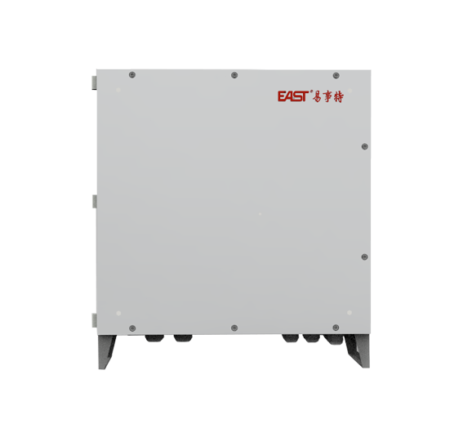
光伏通讯箱
连接逆变器、环境采集器、电表、箱变等多类设备，支持PLC、RS485、光纤及无线多种通讯方式，稳定对接运维后台，助力光伏系统高效管理。
PV Communication Cable
Connects to inverters, environment sensors, electricity meters, box-type transformers and other equipment. Supports PLC, RS485, fiber optic and wireless communication modes, enabling stable connection to the O&M backend for efficient PV system management.
产品特点
产品特点

设备兼容性广
可连接逆变器、环境采集器、电表、箱式变压器及其他设备
丰富的通信接口
支持PLC、RS485、光纤和无线通信模式
稳定的数据传输
与运维后端的可靠连接
高效系统管理
优化光伏系统的运行并提高管理效率
Product Features
Wide device compatibility
- Connects to inverters, environment sensors, electricity meters, box-type transformers and other equipment
Rich communication interfaces
- Supports PLC, RS485, fiber optic and wireless communication modes
Stable data transmission
- Reliable connection to the O&M backend
Efficient system management
- Optimizes PV system operation and improves management efficiency
技术参数
类别 |  | 参数
接口 | RS485 | 8路，波特率2400-115200bps  (2路最大115200,6路最大38400) | 预留1路电表通讯，预留1路环境检测仪，  预留1路箱变变电站，2路电力载波集中控  制器(或2路逆变器),1路PID模块通讯，  1路调试口，1路预留
接口 | 模拟量输入(AI) | 4路，1路0-12V,3路4mA-20mA | 预留(用于连接A型的环境监测传感器),  通讯箱连接防雷器告警输出
接口 | 数字量输入(DI) | 4路，12Vdc,无源干接点信号接入 | 可用于连接DI型的电网调度命令或者告警信号
接口 | 数字量输出(DO) | 6路，干接点(支持220Va.c/5A和  30Vdc/5A) | 继电器输出(NO+NC),6对常开/常闭触点
接口 | 网 口 | 4路，百兆以太网口， RJ45
接口 | SFP端口(以太网光口) | 2路，单模，干兆速率端口 | 组环网
输入 | 三相输入电压 | 640Vac-920Vac
其它 | 功耗 | <70W
输出 | PID输出电压 | 300Vd.c-750Vdc
PLC CCO相关技术参数
PLC通讯波特率 |  | 38400bps | 默认38400bps,与数据采集器通讯采用  RS485接口
PLC通信协议 |  | 透传
PLC调制方式 |  | OFDM(正交频分复用)
PLC载波频率 |  | 2.441-5.615MHz | 0.7-12MHz(支持频段划分，默认频段1)
PLC最远传输距离 |  | 1000米 | 允许中继延长距离
PLC CCO最大连接  PLC STA数量 |  | 20pes | 可超过20个，建议20个组网，透传延时  更低
其它
PID输出电压 |  | 300Vd.c-750Vdc

Technical Specifications

Category |  | Parameters
Interface | RS485 | 8 channels, baud rate 2400–115200 bps(2 channels up to 115200 bps, 6 channels up to 38400 bps) | 1 reserved channel for meter communication, 1 reserved channel for environmental monitor, 1 reserved channel for box-type substation, 2 channels for power line carrier central controller (or 2 inverters), 1 channel for PID module communication, 1 debug port, 1 reserved channel
Interface | Analog Input (AI) | 4 channels: 1 channel 0–12 V, 3 channels 4–20 mA | Reserved (for connecting Type A environmental monitoring sensors), communication cabinet connected to lightning arrester alarm output
Interface | Digital Input (DI) | 4 channels, 12 VDC, passive dry contact input | Can be used to connect DI-type grid dispatching commands or alarm signals
Interface | Digital Output (DO) | 6 channels, dry contact (supports 220 VAC/5A and 30 VDC/5A) | Relay output (NO+NC), 6 pairs of normally open / normally closed contacts
Interface | Ethernet Port | 4 channels, 100M Ethernet port, RJ45
Interface | SFP Port (Ethernet Optical Port) | 2 channels, single-mode, Gigabit port | Ring network grouping
Input | 3-Phase Input Voltage | 640–920 VAC
Others | Power Consumption | < 70 W
Output | PID Output Voltage | 300–750 VDC
Technical Parameters Related to PLC CCO
PLC communication baud rate |  | 38400bps | Default: 38400 bps, communicates with data collector via RS485 interface
PLC communication protocol |  | transparent transmission
PLC modulation mode |  | OFDM (Orthogonal Frequency Division Multiplexing)
PLC carrier frequency |  | 2.441-5.615MHz | 0.7–12 MHz (supports band division, default band: 1)
Maximum PLC transmission distance |  | 1000m | Relay extension supported for longer distance.
Maximum number of PLC STAs connectable to PLC CCO |  | 20pes | Supports more than 20 nodes; 20 nodes recommended for networking with lower transparent transmission delay.
Others
PID output voltage |  | 300Vd.c-750Vdc

