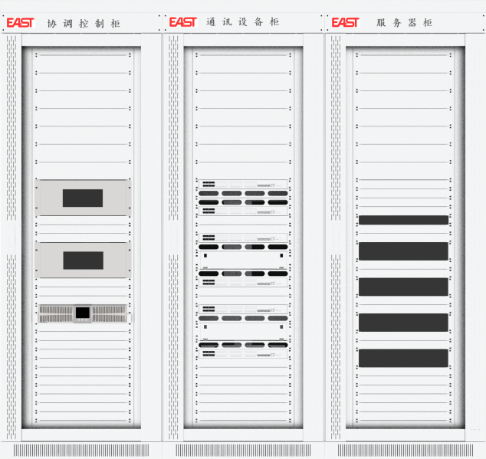
监控屏
易事特eDome监控屏采用标准电力监控屏柜，集成eDome系列监控系统核心软件及硬件设备，配套防火墙、网络安全、电力隔离等软硬件设备，为电力数据安全和电站可靠运行保驾护航。
Monitoring Panel
EAST eDome Monitoring Panel adopts standard power monitoring cabinets, integrating core eDome monitoring system software/hardware, firewalls, network security and power isolation devices to protect power data security and station reliable operation.
产品特点
灵活简洁
光纤接口与网络接口数量根据需求灵活选择
屏柜间极简接线，方便现场施工
四面可维护设计，不受安装空间限制
集成eDome系列监控软件，广泛适用于光伏系统、储能系统、光 储 系 统、微 网等应用场景
安全可靠
双电源供电+UPS，保障系统供电可靠性
配备软硬件防火墙
电力专用网络隔离
Product Features

Flexible & Concise
- Flexible fiber & network port configuration
- Minimal wiring between cabinets for easy on-site installation
- Four-sided maintenance, installation-space independent
- Integrated eDome monitoring software, widely applicable to PV, energy storage, PV-storage hybrid, and microgrid systems

Secure & Reliable
- Dual power supply + UPS for high availability
- Hardware & software firewalls
- Dedicated power network isolation
技术参数
监控系统
服务器 | 工控机/服务器可选
监控软件 | eDome
系统规格
光纤接口 | 4光/8光/16光/24光可选
网络接口 | 8电/16电/24电可选
防火墙 | 选配
隔离装置 | 选配
加密装置 | 选配
电源
电源电压/频率 | AC220V/50Hz
功耗 | ≤2500W
环境参数
冷却方式 | 自然风冷
运行环境温度 | 5℃~45℃
运行环境湿度 | 5%~95%
屏柜参数
防护等级 | IP20
单柜尺寸(宽x深x高) | 800×1000×2260(mm)  800×600×2260(mm)

Technical Specifications

Monitoring System
Server | Industrial PC / Server (optional)
Monitoring Software | eDome
System Specifications
Fiber Interface | 4/8/16/24 fiber ports (optional)
Network Interface | 8/16/24 Ethernet ports (optional)
Firewall | Optional
Isolation Device | Optional
Encryption Device | Optional
Power
Power Supply Voltage / Frequency | AC220V/50Hz
Power Consumption | ≤2500W
Environmental Parameters
Cooling Method | Natural air cooling
Operating Ambient Temperature | 5℃~45℃
Operating Ambient Humidity | 5%~95%
Cabinet Parameters
Protection Class | IP20
Single Cabinet Dimensions (W×D×H) | 800×1000×2260(mm)  800×600×2260(mm)

