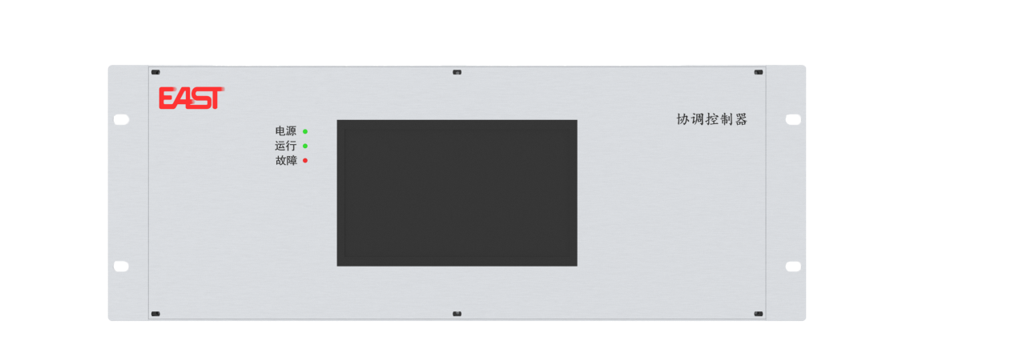

协调控制器
易事特EAPMS-DM600协调控制器，采用DSP+ARM+FPGA的高性能硬件平台，能够主动快速感知电网运行状态，具备一次调频、动态无功调压、惯量支撑等功能，实现对电网频率和电压的主动支撑，增强电网的稳定性。
EAPMS-DM600 Coordination Controller
Powered by a high-performance DSP+ARM+FPGA platform, it quickly senses grid conditions and provides primary frequency control, dynamic reactive voltage regulation, and inertia support to actively stabilize grid frequency and voltage.

产品特点
高速GOOSE组网
- 支持GOOSE组网，实现快速通讯，通讯延时2ms
微秒级测量控制技术
- 电网频率采样、计算周期10ms一次
- 调频动作时间20ms
强大的协调控制能力
- 单装置最大支持128台PCS
- 具备智能SOC均衡算法
- 源网荷储全面协同控制

Product Features
High-Speed GOOSE Networking
- Supports GOOSE networking for high-speed communication with latency ≤ 2 ms
Microsecond-Level Measurement & Control
- Grid frequency sampling & calculation cycle: 10 ms
- Frequency regulation response time: 20 ms
Powerful Coordinated Control
- Single unit supports up to 128 PCS
- Integrated intelligent SOC balancing algorithm
- Full coordinated control of source, grid, load and storage

技术参数
产品型号 EAPMS-DM600
系统规格
电压/电流采样 | 6个并网点
开关量输入 | 16路
开关量输出 | 8路
直流量输入 | 8路
可接入PCS数量 | 128台
显示 | 7寸触摸彩色液晶屏
防护等级 | IP20
产品尺寸(宽x深x高) | 480×300×177(mm)
性能参数
一次调频动作时间 | ≤20ms
电流/电压误差 | ≤0.2%(0.2级)
功率/电度误差 | ≤0.5%(0.5级)
频率测量误差 | ≤0.001Hz
通讯参数
通讯接口 | RS485(4路),网口(4路), USB(2.0)1路
通讯协议 | IEC61850 MMS、GOOSE、 MODBUS_RTU等
Technical Specifications
Product Model EAPMS-DM600
System Specifications
Voltage/Current Sampling | 6 Grid-Connection Points
Digital Input (DI) | 16 Channels
Digital Output (DO) | 8 Channels
DC Input | 8 Channels
Number of Connectable PCS | 128 Units
Display | 7-inch Touch Color LCD Screen
IP Rating | IP20
Dimensions (W×D×H) | 480×300×177(mm)
Performance Parameters
Primary Frequency Modulation Action Time | ≤20ms
Current/Voltage Error | ≤0.2%(Class 0.2)
Power/Energy Error | ≤0.5%(Class 0.2)
Frequency Measurement Error | ≤0.001Hz
Communication Parameters
Communication Interface | RS485 (4 channels), Ethernet port (4 channels), USB 2.0 (1 channel)
Communication Protocol | IEC61850 MMS, GOOSE, MODBUS_RTU, etc.

